Shah Md. Tasrif Rahman

* Encoding: UTF-8.

PRESERVE.
SET DECIMAL DOT.

* Since I messed up while generating the output of my first assignment, I'll be properly segmenting my code so that the final output is clean and reproducible using whatever syntax I used during data analysis.

* /Step-1: Data loading/

GET DATA /TYPE=TXT
/FILE="E:\Statistical Softwares\SPSS\CUSPC-SPSS\Class-7\salary regression data.csv"
/ENCODING='UTF8'
/DELIMITERS=","
/QUALIFIER='"'
/ARRANGEMENT=DELIMITED
/FIRSTCASE=2
/DATATYPEMIN PERCENTAGE=95.0
/VARIABLES=
employee_id AUTO
age AUTO
education_years AUTO
experience_years AUTO
training_hours AUTO
region AUTO
annual_salary_k AUTO
/MAP.
RESTORE.
CACHE.
EXECUTE.

Data written to the working file.
7 variables and 250 cases written.
Variable: employee_id Type: Number Format : F4
Variable: age Type: Number Format : F2
Variable: education_years Type: Number Format : F4.1
Variable: experience_years Type: Number Format : F4.1
Variable: training_hours Type: Number Format : F2
Variable: region Type: String Format : A8
Variable: annual_salary_k Type: Number Format : F4.1

Substitute the following to build syntax for these data.
/VARIABLES=
employee_id F4
age F2
education_years F4.1
experience_years F4.1
training_hours F2
region A8
annual_salary_k F4.1

DATASET NAME DataSet1 WINDOW=FRONT.

* /Step-2: Data labelling/

VARIABLE LABELS
employee_id 'Anonymised employee identifier'
age 'Age at time of extract (Years)'
education_years 'Total years of completed formal education (Years)'
experience_years 'Total years of professional work experience (Years)'
training_hours 'Company-funded training received in the last 12 months (Hours)'
region 'Office location type (Urban/Suburban/Rural)'
annual_salary_k 'Gross annual salary (USD thousands)'.
EXECUTE.

VARIABLE LEVEL employee_id (NOMINAL).
EXECUTE.

* /Step-3: Data Checking/

DATASET ACTIVATE DataSet1.
FREQUENCIES VARIABLES=employee_id age education_years experience_years training_hours region
annual_salary_k
/FORMAT=NOTABLE
/STATISTICS=RANGE MINIMUM MAXIMUM
/ORDER=ANALYSIS.

Frequencies

[DataSet1]

Statistics
 |  | Anonymised employee identifier | Age at time of extract (Years) | Total years of completed formal education (Years) | Total years of professional work experience (Years) | Company-funded training received in the last 12 months (Hours) | Office location type (Urban/Suburban/Rural) | Gross annual salary (USD thousands)
N | Valid | 250 | 250 | 250 | 250 | 250 | 250 | 250
N | Missing | 0 | 0 | 0 | 0 | 0 | 0 | 0
Range |  | 249 | 24 | 11.6 | 19.6 | 75 |  | 50.2
Minimum |  | 5001 | 22 | 10.1 | .0 | 0 |  | 37.2
Maximum |  | 5250 | 46 | 21.7 | 19.6 | 75 |  | 87.4

FREQUENCIES VARIABLES=region
/ORDER=ANALYSIS.

Frequencies

Statistics
Office location type (Urban/Suburban/Rural)
N | Valid | 250
N | Missing | 0

Office location type (Urban/Suburban/Rural)
 |  | Frequency | Percent | Valid Percent | Cumulative Percent
Valid | Rural | 44 | 17.6 | 17.6 | 17.6
Valid | Suburban | 75 | 30.0 | 30.0 | 47.6
Valid | Urban | 131 | 52.4 | 52.4 | 100.0
Valid | Total | 250 | 100.0 | 100.0

* All 250 observations are present in the given dataset, and no impossible values were found. We can safely proceed to the next steps of analysis.

* /Task 1/
.
* Custom Tables.
CTABLES
/VLABELS VARIABLES=age education_years experience_years training_hours annual_salary_k
DISPLAY=LABEL
/TABLE age [COUNT 'Complete cases (n)' F40.0, MINIMUM, MAXIMUM, MEAN, MEDIAN, STDDEV] +
education_years [COUNT 'Complete cases (n)' F40.0, MINIMUM, MAXIMUM, MEAN, MEDIAN, STDDEV] +
experience_years [COUNT 'Complete cases (n)' F40.0, MINIMUM, MAXIMUM, MEAN, MEDIAN, STDDEV] +
training_hours [COUNT 'Complete cases (n)' F40.0, MINIMUM, MAXIMUM, MEAN, MEDIAN, STDDEV] +
annual_salary_k [COUNT 'Complete cases (n)' F40.0, MINIMUM, MAXIMUM, MEAN, MEDIAN, STDDEV]
/CRITERIA CILEVEL=95.

Custom Tables

 | Complete cases (n) | Minimum | Maximum | Mean | Median | Standard Deviation
Age at time of extract (Years) | 250 | 22 | 46 | 30 | 30 | 6
Total years of completed formal education (Years) | 250 | 10.1 | 21.7 | 16.1 | 16.3 | 2.3
Total years of professional work experience (Years) | 250 | .0 | 19.6 | 7.7 | 7.7 | 4.9
Company-funded training received in the last 12 months (Hours) | 250 | 0 | 75 | 31 | 31 | 15
Gross annual salary (USD thousands) | 250 | 37.2 | 87.4 | 61.8 | 61.7 | 10.1

* /Task 2/

* /Graph-2a/

* Chart Builder.
GGRAPH
/GRAPHDATASET NAME="graphdataset" VARIABLES=annual_salary_k MISSING=LISTWISE REPORTMISSING=NO
/GRAPHSPEC SOURCE=INLINE
/FRAME OUTER=NO INNER=NO
/GRIDLINES XAXIS=NO YAXIS=YES
/STYLE GRADIENT=NO.
BEGIN GPL
SOURCE: s=userSource(id("graphdataset"))
DATA: annual_salary_k=col(source(s), name("annual_salary_k"))
GUIDE: axis(dim(1), label("Gross annual salary (USD thousands)"))
GUIDE: axis(dim(2), label("Frequency"))
GUIDE: text.title(label("Histogram of Gross annual salary (USD thousands)"))
ELEMENT: interval(position(summary.count(bin.rect(annual_salary_k))),
shape.interior(shape.square))
END GPL.

GGraph

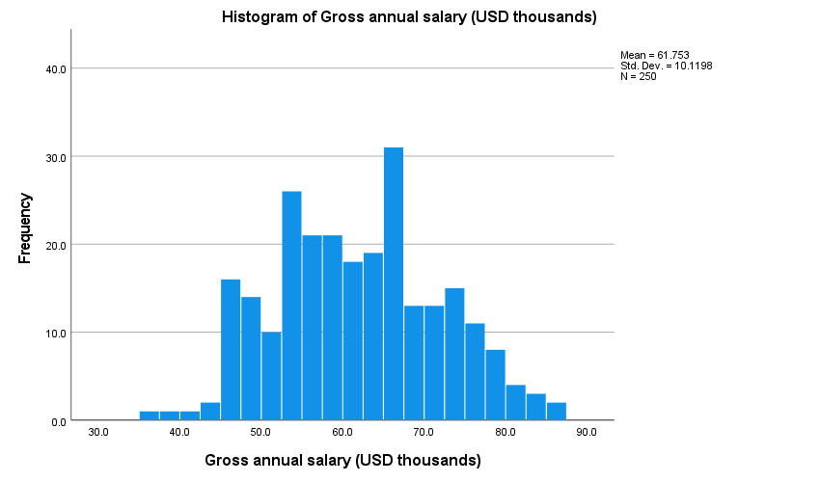

* /Graph-2b/

* Chart Builder.
GGRAPH
/GRAPHDATASET NAME="graphdataset" VARIABLES=region COUNT()[name="COUNT"] MISSING=LISTWISE
REPORTMISSING=NO
/GRAPHSPEC SOURCE=INLINE
/FRAME OUTER=NO INNER=NO
/GRIDLINES XAXIS=NO YAXIS=YES
/STYLE GRADIENT=NO.
BEGIN GPL
SOURCE: s=userSource(id("graphdataset"))
DATA: region=col(source(s), name("region"), unit.category())
DATA: COUNT=col(source(s), name("COUNT"))
GUIDE: axis(dim(1), label("Office location type (Urban/Suburban/Rural)"))
GUIDE: axis(dim(2), label("Percent"))
GUIDE: text.title(label("Bar chart of Office location type (Urban/Suburban/Rural)"))
SCALE: linear(dim(2), include(0))
ELEMENT: interval(position(summary.percent(region*COUNT, base.all(acrossPanels()))),
shape.interior(shape.square))
END GPL.

GGraph

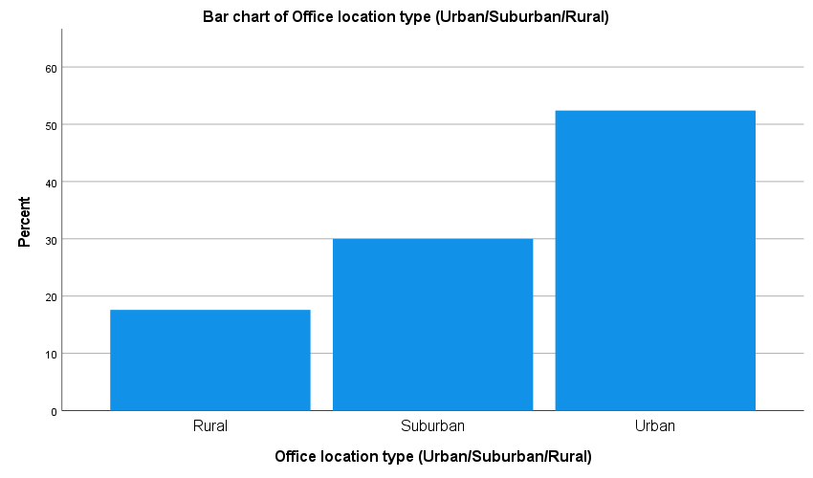

* /Graph-2c/

* Chart Builder.
GGRAPH
/GRAPHDATASET NAME="graphdataset" VARIABLES=region annual_salary_k MISSING=LISTWISE
REPORTMISSING=NO
/GRAPHSPEC SOURCE=INLINE
/FRAME OUTER=NO INNER=NO
/GRIDLINES XAXIS=NO YAXIS=YES
/STYLE GRADIENT=NO.
BEGIN GPL
SOURCE: s=userSource(id("graphdataset"))
DATA: region=col(source(s), name("region"), unit.category())
DATA: annual_salary_k=col(source(s), name("annual_salary_k"))
DATA: id=col(source(s), name("$CASENUM"), unit.category())
COORD: transpose()
GUIDE: axis(dim(1), label("Office location type (Urban/Suburban/Rural)"))
GUIDE: axis(dim(2), label("Gross annual salary (USD thousands)"))
GUIDE: text.title(label("Boxplot of Gross annual salary (USD thousands) split by Office location type (Urban/Suburban/Rural)"))
SCALE: linear(dim(2), include(0))
ELEMENT: schema(position(bin.quantile.letter(region*annual_salary_k)), label(id))
END GPL.

GGraph

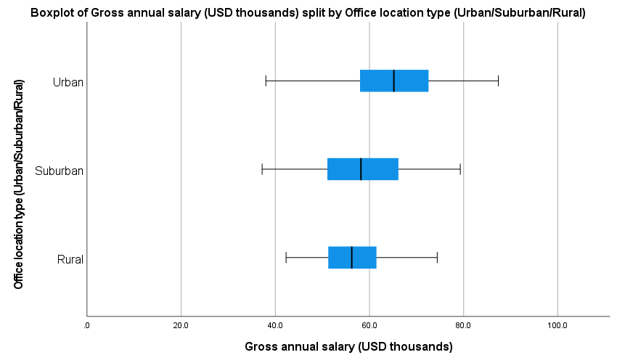

* /Graph-2d_1/

* Chart Builder.
GGRAPH
/GRAPHDATASET NAME="graphdataset" VARIABLES=education_years annual_salary_k MISSING=LISTWISE
REPORTMISSING=NO
/GRAPHSPEC SOURCE=INLINE
/FITLINE TOTAL=YES SUBGROUP=NO
/FRAME OUTER=NO INNER=NO
/GRIDLINES XAXIS=NO YAXIS=YES
/STYLE GRADIENT=NO.
BEGIN GPL
SOURCE: s=userSource(id("graphdataset"))
DATA: education_years=col(source(s), name("education_years"))
DATA: annual_salary_k=col(source(s), name("annual_salary_k"))
GUIDE: axis(dim(1), label("Total years of completed formal education (Years)"))
GUIDE: axis(dim(2), label("Gross annual salary (USD thousands)"))
GUIDE: text.title(label("Scatter Plot of Gross annual salary (USD thousands) by Total years of ",
"completed formal education (Years)"))
ELEMENT: point(position(education_years*annual_salary_k))
END GPL.

GGraph

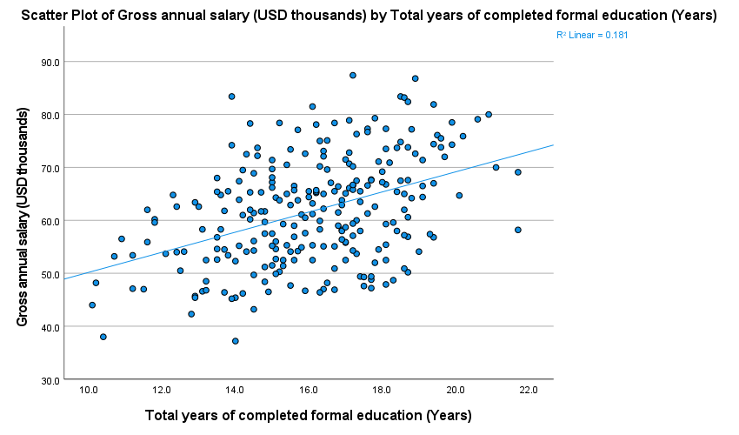

* /Graph-2d_2/

* Chart Builder.
GGRAPH
/GRAPHDATASET NAME="graphdataset" VARIABLES=experience_years annual_salary_k MISSING=LISTWISE
REPORTMISSING=NO
/GRAPHSPEC SOURCE=INLINE
/FITLINE TOTAL=YES SUBGROUP=NO
/FRAME OUTER=NO INNER=NO
/GRIDLINES XAXIS=NO YAXIS=YES
/STYLE GRADIENT=NO.
BEGIN GPL
SOURCE: s=userSource(id("graphdataset"))
DATA: experience_years=col(source(s), name("experience_years"))
DATA: annual_salary_k=col(source(s), name("annual_salary_k"))
GUIDE: axis(dim(1), label("Total years of professional work experience (Years)"))
GUIDE: axis(dim(2), label("Gross annual salary (USD thousands)"))
GUIDE: text.title(label("Scatter Plot of Gross annual salary (USD thousands) by Total years of ",
"professional work experience (Years)"))
ELEMENT: point(position(experience_years*annual_salary_k))
END GPL.

GGraph

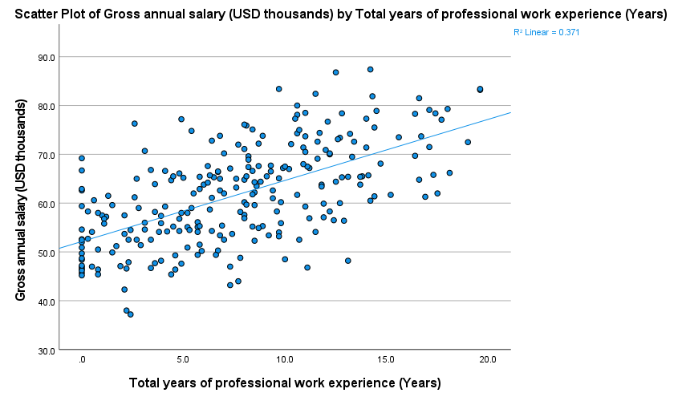

* /Graph-2d_3/

* Chart Builder.
GGRAPH
/GRAPHDATASET NAME="graphdataset" VARIABLES=training_hours annual_salary_k MISSING=LISTWISE
REPORTMISSING=NO
/GRAPHSPEC SOURCE=INLINE
/FITLINE TOTAL=YES SUBGROUP=NO
/FRAME OUTER=NO INNER=NO
/GRIDLINES XAXIS=NO YAXIS=YES
/STYLE GRADIENT=NO.
BEGIN GPL
SOURCE: s=userSource(id("graphdataset"))
DATA: training_hours=col(source(s), name("training_hours"))
DATA: annual_salary_k=col(source(s), name("annual_salary_k"))
GUIDE: axis(dim(1), label("Company-funded training received in the last 12 months (Hours)"))
GUIDE: axis(dim(2), label("Gross annual salary (USD thousands)"))
GUIDE: text.title(label("Scatter Plot of Gross annual salary (USD thousands) by Company-funded ",
"training received in the last 12 months (Hours)"))
ELEMENT: point(position(training_hours*annual_salary_k))
END GPL.

GGraph

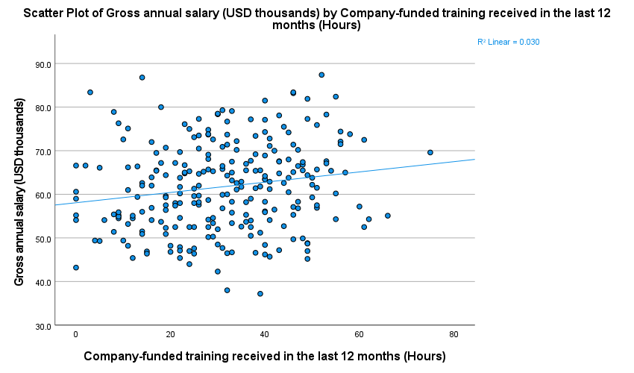

* /Task 3/

* /Main Table/

CORRELATIONS
/VARIABLES=age education_years experience_years training_hours annual_salary_k
/PRINT=TWOTAIL NOSIG FULL
/MISSING=PAIRWISE.

Correlations

Correlations
 |  | Age at time of extract (Years) | Total years of completed formal education (Years) | Total years of professional work experience (Years) | Company-funded training received in the last 12 months (Hours) | Gross annual salary (USD thousands)
Age at time of extract (Years) | Pearson Correlation | 1 | .420** | .785** | .098 | .624**
Age at time of extract (Years) | Sig. (2-tailed) |  | .000 | .000 | .123 | .000
Age at time of extract (Years) | N | 250 | 250 | 250 | 250 | 250
Total years of completed formal education (Years) | Pearson Correlation | .420** | 1 | .007 | -.031 | .425**
Total years of completed formal education (Years) | Sig. (2-tailed) | .000 |  | .910 | .630 | .000
Total years of completed formal education (Years) | N | 250 | 250 | 250 | 250 | 250
Total years of professional work experience (Years) | Pearson Correlation | .785** | .007 | 1 | .126* | .609**
Total years of professional work experience (Years) | Sig. (2-tailed) | .000 | .910 |  | .046 | .000
Total years of professional work experience (Years) | N | 250 | 250 | 250 | 250 | 250
Company-funded training received in the last 12 months (Hours) | Pearson Correlation | .098 | -.031 | .126* | 1 | .173**
 | Sig. (2-tailed) | .123 | .630 | .046 |  | .006
 | N | 250 | 250 | 250 | 250 | 250
Gross annual salary (USD thousands) | Pearson Correlation | .624** | .425** | .609** | .173** | 1
Gross annual salary (USD thousands) | Sig. (2-tailed) | .000 | .000 | .000 | .006
Gross annual salary (USD thousands) | N | 250 | 250 | 250 | 250 | 250
**. Correlation is significant at the 0.01 level (2-tailed).
*. Correlation is significant at the 0.05 level (2-tailed).

* /Correlation Matrix/

CORRELATIONS
/VARIABLES=age education_years experience_years training_hours annual_salary_k
/PRINT=TWOTAIL NOSIG LOWER
/MISSING=PAIRWISE.

Correlations
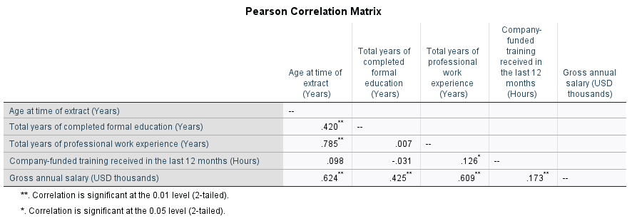
* I had to put an image of the correlation matrix here because SPSS kept breaking the format fsr and I couldn’t export the whole table, which was utterly annoying.

OUTPUT MODIFY
/SELECT TABLES
/IF COMMANDS=["Correlations(LAST)"]
SUBTYPES=["Correlations"]
/TABLECELLS SELECT=[SIGNIFICANCE COUNT]
SELECTDIMENSION=ROWS
APPLYTO=ROW
HIDE=YES
/TABLECELLS
SELECT=[TITLE]
REPLACE="Pearson Correlation Matrix"
/TABLECELLS
SELECT=["CORRELATION"]
SELECTDIMENSION=ROWS
APPLYTO=ROWHEADER
HIDE=YES.

* /Task 4/

REGRESSION
/MISSING LISTWISE
/STATISTICS COEFF OUTS CI(95) R ANOVA
/CRITERIA=PIN(.05) POUT(.10)
/NOORIGIN
/DEPENDENT annual_salary_k
/METHOD=ENTER education_years experience_years training_hours.

Regression

Variables Entered/Removedª
Model | Variables Entered | Variables Removed | Method
1 | Company-funded training received in the last 12 months (Hours), Total years of completed formal education (Years), Total years of professional work experience (Years)^{b} | . | Enter
a. Dependent Variable: Gross annual salary (USD thousands)
b. All requested variables entered.

Model Summary
Model | R | R Square | Adjusted R Square | Std. Error of the Estimate
1 | .749ª | .561 | .555 | 6.7495
a. Predictors: (Constant), Company-funded training received in the last 12 months (Hours), Total years of completed formal education (Years), Total years of professional work experience (Years)

ANOVAª
Model |  | Sum of Squares | df | Mean Square | F | Sig.
1 | Regression | 14293.667 | 3 | 4764.556 | 104.588 | .000^{b}
1 | Residual | 11206.636 | 246 | 45.555
1 | Total | 25500.302 | 249
a. Dependent Variable: Gross annual salary (USD thousands)
b. Predictors: (Constant), Company-funded training received in the last 12 months (Hours), Total years of completed formal education (Years), Total years of professional work experience (Years)

Coefficientsª
Model |  | Unstandardized Coefficients |  | Standardized Coefficients | t | Sig. | 95.0% Confidence Interval for B
 |  | B | Std. Error | Beta | t | Sig. | Lower Bound | Upper Bound
1 | (Constant) | 19.541 | 3.266 |  | 5.983 | .000 | 13.108 | 25.974
1 | Total years of completed formal education (Years) | 1.895 | .189 | .425 | 10.038 | .000 | 1.523 | 2.267
1 | Total years of professional work experience (Years) | 1.217 | .088 | .592 | 13.899 | .000 | 1.044 | 1.389
1 | Company-funded training received in the last 12 months (Hours) | .076 | .029 | .111 | 2.604 | .010 | .018 | .133
a. Dependent Variable: Gross annual salary (USD thousands)

* Comment-1: These three factors (formal education, years of professional work experience, and hours of company-funded training) together account for 56.1% of the variation in salary, which we found from the value of R square.
* Comment-2: The estimated change in annual salary associated with one additional year of education, holding experience and training constant is 1895 USD on average.
* Comment-3: The estimated change in annual salary associated with one additional year of experience, holding year of education and training constant is 1217 USD on average.
* Comment-4: From regression analysis, we can see that the estimated change in annual salary associated with one additional hour of company-funded training, holding other factors constant is 76 USD on average.
* For this specific factor, t(246) = 2.604, p = .010, which is statistically significant at 5% level of significance.
* Thus we can conclude that, even though the increase in salary for one additional hour of company-funded training isn't that much compared to one unit of change in other factors, it's still statistically significant.
* Which means the money currently spent on training is associated with measurably higher pay.

SAVE OUTFILE='E:\Statistical Softwares\SPSS\CUSPC-SPSS\Assignments\Assignment-2\Assignment-2_Dataset.sav'
/COMPRESSED.

Appendix:

* Encoding: UTF-8.

PRESERVE.
SET DECIMAL DOT.

* Since I messed up while generating the output of my first assignment, I'll be properly segmenting my code so that the final output is clean and reproducible using whatever syntax I used during data analysis.

* /Step-1: Data loading/

GET DATA /TYPE=TXT
/FILE="E:\Statistical Softwares\SPSS\CUSPC-SPSS\Class-7\salary regression data.csv"
/ENCODING='UTF8'
/DELIMITERS=","
/QUALIFIER='"'
/ARRANGEMENT=DELIMITED
/FIRSTCASE=2
/DATATYPEMIN PERCENTAGE=95.0
/VARIABLES=
employee_id AUTO
age AUTO
education_years AUTO
experience_years AUTO
training_hours AUTO
region AUTO
annual_salary_k AUTO
/MAP.
RESTORE.
CACHE.
EXECUTE.
DATASET NAME DataSet1 WINDOW=FRONT.

* /Step-2: Data labelling/

VARIABLE LABELS
employee_id 'Anonymised employee identifier'
age 'Age at time of extract (Years)'
education_years 'Total years of completed formal education (Years)'
experience_years 'Total years of professional work experience (Years)'
training_hours 'Company-funded training received in the last 12 months (Hours)'
region 'Office location type (Urban/Suburban/Rural)'
annual_salary_k 'Gross annual salary (USD thousands)'.
EXECUTE.

VARIABLE LEVEL employee_id (NOMINAL).
EXECUTE.

* /Step-3: Data Checking/

DATASET ACTIVATE DataSet1.
FREQUENCIES VARIABLES=employee_id age education_years experience_years training_hours region
annual_salary_k
/FORMAT=NOTABLE
/STATISTICS=RANGE MINIMUM MAXIMUM
/ORDER=ANALYSIS.

FREQUENCIES VARIABLES=region
/ORDER=ANALYSIS.

* All 250 observations are present in the given dataset, and no impossible values were found. We can safely proceed to the next steps of analysis.

* /Task 1/
.
* Custom Tables.
CTABLES
/VLABELS VARIABLES=age education_years experience_years training_hours annual_salary_k
DISPLAY=LABEL
/TABLE age [COUNT 'Complete cases (n)' F40.0, MINIMUM, MAXIMUM, MEAN, MEDIAN, STDDEV] +
education_years [COUNT 'Complete cases (n)' F40.0, MINIMUM, MAXIMUM, MEAN, MEDIAN, STDDEV] +
experience_years [COUNT 'Complete cases (n)' F40.0, MINIMUM, MAXIMUM, MEAN, MEDIAN, STDDEV] +
training_hours [COUNT 'Complete cases (n)' F40.0, MINIMUM, MAXIMUM, MEAN, MEDIAN, STDDEV] +
annual_salary_k [COUNT 'Complete cases (n)' F40.0, MINIMUM, MAXIMUM, MEAN, MEDIAN, STDDEV]
/CRITERIA CILEVEL=95.

* /Task 2/

* /Graph-2a/

* Chart Builder.
GGRAPH
/GRAPHDATASET NAME="graphdataset" VARIABLES=annual_salary_k MISSING=LISTWISE REPORTMISSING=NO
/GRAPHSPEC SOURCE=INLINE
/FRAME OUTER=NO INNER=NO
/GRIDLINES XAXIS=NO YAXIS=YES
/STYLE GRADIENT=NO.
BEGIN GPL
SOURCE: s=userSource(id("graphdataset"))
DATA: annual_salary_k=col(source(s), name("annual_salary_k"))
GUIDE: axis(dim(1), label("Gross annual salary (USD thousands)"))
GUIDE: axis(dim(2), label("Frequency"))
GUIDE: text.title(label("Histogram of Gross annual salary (USD thousands)"))
ELEMENT: interval(position(summary.count(bin.rect(annual_salary_k))),
shape.interior(shape.square))
END GPL.

* /Graph-2b/

* Chart Builder.
GGRAPH
/GRAPHDATASET NAME="graphdataset" VARIABLES=region COUNT()[name="COUNT"] MISSING=LISTWISE
REPORTMISSING=NO
/GRAPHSPEC SOURCE=INLINE
/FRAME OUTER=NO INNER=NO
/GRIDLINES XAXIS=NO YAXIS=YES
/STYLE GRADIENT=NO.
BEGIN GPL
SOURCE: s=userSource(id("graphdataset"))
DATA: region=col(source(s), name("region"), unit.category())
DATA: COUNT=col(source(s), name("COUNT"))
GUIDE: axis(dim(1), label("Office location type (Urban/Suburban/Rural)"))
GUIDE: axis(dim(2), label("Percent"))
GUIDE: text.title(label("Bar chart of Office location type (Urban/Suburban/Rural)"))
SCALE: linear(dim(2), include(0))
ELEMENT: interval(position(summary.percent(region*COUNT, base.all(acrossPanels()))),
shape.interior(shape.square))
END GPL.

* /Graph-2c/

* Chart Builder.
GGRAPH
/GRAPHDATASET NAME="graphdataset" VARIABLES=region annual_salary_k MISSING=LISTWISE
REPORTMISSING=NO
/GRAPHSPEC SOURCE=INLINE
/FRAME OUTER=NO INNER=NO
/GRIDLINES XAXIS=NO YAXIS=YES
/STYLE GRADIENT=NO.
BEGIN GPL
SOURCE: s=userSource(id("graphdataset"))
DATA: region=col(source(s), name("region"), unit.category())
DATA: annual_salary_k=col(source(s), name("annual_salary_k"))
DATA: id=col(source(s), name("$CASENUM"), unit.category())
COORD: transpose()
GUIDE: axis(dim(1), label("Office location type (Urban/Suburban/Rural)"))
GUIDE: axis(dim(2), label("Gross annual salary (USD thousands)"))
GUIDE: text.title(label("Boxplot of Gross annual salary (USD thousands) split by Office location type (Urban/Suburban/Rural)"))
SCALE: linear(dim(2), include(0))
ELEMENT: schema(position(bin.quantile.letter(region*annual_salary_k)), label(id))
END GPL.

* /Graph-2d_1/

* Chart Builder.
GGRAPH
/GRAPHDATASET NAME="graphdataset" VARIABLES=education_years annual_salary_k MISSING=LISTWISE
REPORTMISSING=NO
/GRAPHSPEC SOURCE=INLINE
/FITLINE TOTAL=YES SUBGROUP=NO
/FRAME OUTER=NO INNER=NO
/GRIDLINES XAXIS=NO YAXIS=YES
/STYLE GRADIENT=NO.
BEGIN GPL
SOURCE: s=userSource(id("graphdataset"))
DATA: education_years=col(source(s), name("education_years"))
DATA: annual_salary_k=col(source(s), name("annual_salary_k"))
GUIDE: axis(dim(1), label("Total years of completed formal education (Years)"))
GUIDE: axis(dim(2), label("Gross annual salary (USD thousands)"))
GUIDE: text.title(label("Scatter Plot of Gross annual salary (USD thousands) by Total years of ",
"completed formal education (Years)"))
ELEMENT: point(position(education_years*annual_salary_k))
END GPL.

* /Graph-2d_2/

* Chart Builder.
GGRAPH
/GRAPHDATASET NAME="graphdataset" VARIABLES=experience_years annual_salary_k MISSING=LISTWISE
REPORTMISSING=NO
/GRAPHSPEC SOURCE=INLINE
/FITLINE TOTAL=YES SUBGROUP=NO
/FRAME OUTER=NO INNER=NO
/GRIDLINES XAXIS=NO YAXIS=YES
/STYLE GRADIENT=NO.
BEGIN GPL
SOURCE: s=userSource(id("graphdataset"))
DATA: experience_years=col(source(s), name("experience_years"))
DATA: annual_salary_k=col(source(s), name("annual_salary_k"))
GUIDE: axis(dim(1), label("Total years of professional work experience (Years)"))
GUIDE: axis(dim(2), label("Gross annual salary (USD thousands)"))
GUIDE: text.title(label("Scatter Plot of Gross annual salary (USD thousands) by Total years of ",
"professional work experience (Years)"))
ELEMENT: point(position(experience_years*annual_salary_k))
END GPL.

* /Graph-2d_3/

* Chart Builder.
GGRAPH
/GRAPHDATASET NAME="graphdataset" VARIABLES=training_hours annual_salary_k MISSING=LISTWISE
REPORTMISSING=NO
/GRAPHSPEC SOURCE=INLINE
/FITLINE TOTAL=YES SUBGROUP=NO
/FRAME OUTER=NO INNER=NO
/GRIDLINES XAXIS=NO YAXIS=YES
/STYLE GRADIENT=NO.
BEGIN GPL
SOURCE: s=userSource(id("graphdataset"))
DATA: training_hours=col(source(s), name("training_hours"))
DATA: annual_salary_k=col(source(s), name("annual_salary_k"))
GUIDE: axis(dim(1), label("Company-funded training received in the last 12 months (Hours)"))
GUIDE: axis(dim(2), label("Gross annual salary (USD thousands)"))
GUIDE: text.title(label("Scatter Plot of Gross annual salary (USD thousands) by Company-funded ",
"training received in the last 12 months (Hours)"))
ELEMENT: point(position(training_hours*annual_salary_k))
END GPL.

* /Task 3/

* /Main Table/

CORRELATIONS
/VARIABLES=age education_years experience_years training_hours annual_salary_k
/PRINT=TWOTAIL NOSIG FULL
/MISSING=PAIRWISE.

* /Correlation Matrix/

CORRELATIONS
/VARIABLES=age education_years experience_years training_hours annual_salary_k
/PRINT=TWOTAIL NOSIG LOWER
/MISSING=PAIRWISE.

OUTPUT MODIFY
/SELECT TABLES
/IF COMMANDS=["Correlations(LAST)"]
SUBTYPES=["Correlations"]
/TABLECELLS SELECT=[SIGNIFICANCE COUNT]
SELECTDIMENSION=ROWS
APPLYTO=ROW
HIDE=YES
/TABLECELLS
SELECT=[TITLE]
REPLACE="Pearson Correlation Matrix"
/TABLECELLS
SELECT=["CORRELATION"]
SELECTDIMENSION=ROWS
APPLYTO=ROWHEADER
HIDE=YES.

* /Task 4/

REGRESSION
/MISSING LISTWISE
/STATISTICS COEFF OUTS CI(95) R ANOVA
/CRITERIA=PIN(.05) POUT(.10)
/NOORIGIN
/DEPENDENT annual_salary_k
/METHOD=ENTER education_years experience_years training_hours.

* Comment-1: These three factors (formal education, years of professional work experience, and hours of company-funded training) together account for 56.1% of the variation in salary, which we found from the value of R square.
* Comment-2: The estimated change in annual salary associated with one additional year of education, holding experience and training constant is 1895 USD on average.
* Comment-3: The estimated change in annual salary associated with one additional year of experience, holding year of education and training constant is 1217 USD on average.
* Comment-4: From regression analysis, we can see that the estimated change in annual salary associated with one additional hour of company-funded training, holding other factors constant is 76 USD on average.
* For this specific factor, t(246) = 2.604, p = .010, which is statistically significant at 5% level of significance.
* Thus we can conclude that, even though the increase in salary for one additional hour of company-funded training isn't that much compared to one unit of change in other factors, it's still statistically significant.
* Which means the money currently spent on training is associated with measurably higher pay.

SAVE OUTFILE='E:\Statistical Softwares\SPSS\CUSPC-SPSS\Assignments\Assignment-2\Assignment-2_Dataset.sav'
/COMPRESSED.

